Introdution:

The term “linearity” in algebra refers to a linear relationship between two or more variables. If we draw this relationship in a two-dimensional space (between two variables), we get a straight line.

Linear regression performs the task to predict a dependent variable value (y) based on a given independent variable (x). So, this regression technique finds out a linear relationship between x (input) and y(output). Hence, the name is Linear Regression. If we plot the independent variable (x) on the x-axis and dependent variable (y) on the y-axis, linear regression gives us a straight line that best fits the data points, as shown in the figure below.

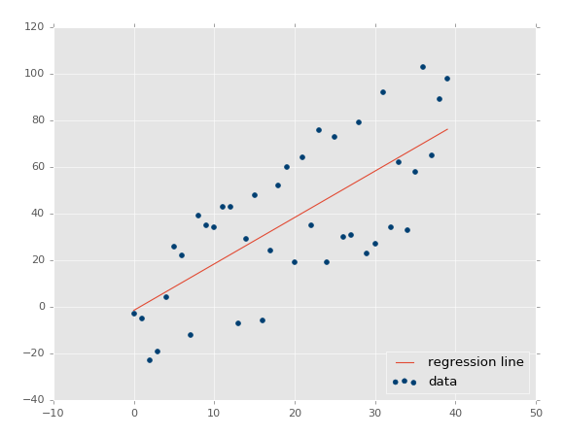

The equation of the above line is :

**Y= mx + b**

X – independent variable

y- dependent variable

M – slope of the line

b –intercept of line in Y when x=0.

*The values that we can control are the intercept(b) and slope(m).There can be multiple straight lines depending upon the values of intercept and slope* .

<https://towardsdatascience.com/a-beginners-guide-to-linear-regression-in-python-with-scikit-learn-83a8f7ae2b4f>

<https://www.kaggle.com/andyxie/beginner-scikit-learn-linear-regression-tutorial>